Database Systems
Fall-2024 Department of Computer Science
The Islamia University Bahawalpur
Class 4th MA

Submitted by: (Khalid Ahmed, S23BDOCS1M01003)
Submitted to: Muhammad Usman Ghani

- Introduction:
  - Background:
The university_professors table contains information about professors, their affiliated universities, associated organizations, and the functions they perform. This single table has redundancy and lacks normalization, making it hard to manage and scale. By splitting it into four related tables — professors, universities, organizations, and affiliations — we aim to create a normalized structure that enhances data integrity and ensures scalability.
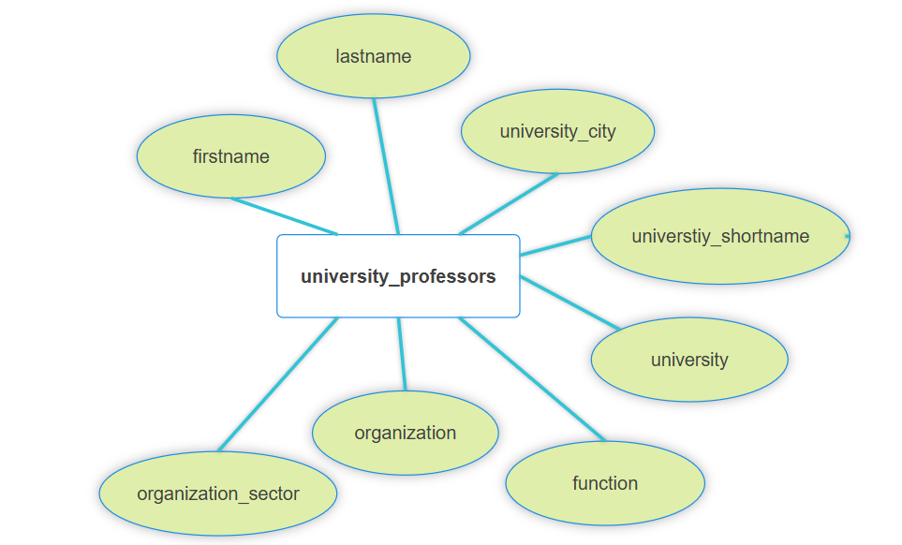
Figure 1 university_professors table with redundancy and lack of normalization.

  - Goal:
The goal is to create a normalized database structure by splitting the university_professors table into multiple tables, ensuring minimal redundancy and easy maintainability. The project aims to implement a robust schema, insert data, and demonstrate various SQL operations like joins, updates, and deletes.
  - Requirements:
- Store professor information (first name, last name, etc.).
- Store university details (short name, city, etc.).
- Track affiliations between professors and organizations.
- Ensure data integrity using primary and foreign keys.
- Allow querying for reports, such as professors by university or organization sector.

- Functional Description:
  - Method of use
This database will primarily be used by university administrators and researchers. Administrators can update professor affiliations, while researchers can query the database for insights, such as the distribution of professors by organization sector or city.

- Entity Data Model
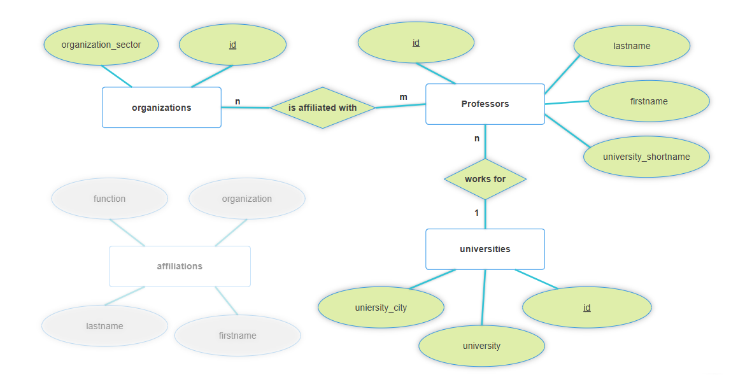

Include a diagram of your data model and describe it in one paragraph. Explain the entities and relationships in your database.

- Table Design (Schema) Screenshots
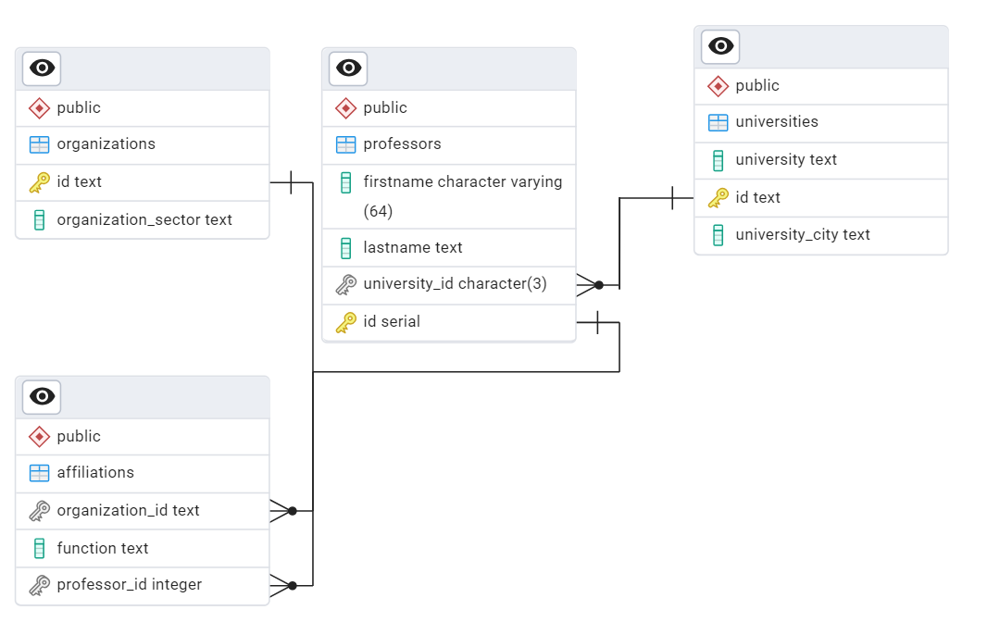

Provide screenshots of your database schema. Include tables, columns, data types, and any constraints.
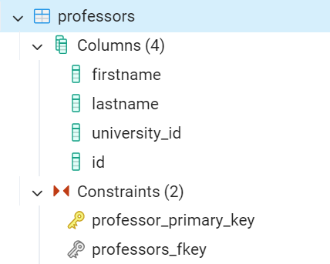
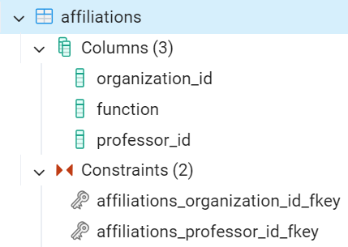
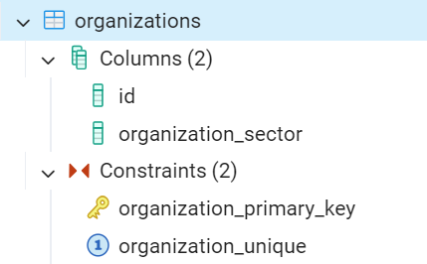
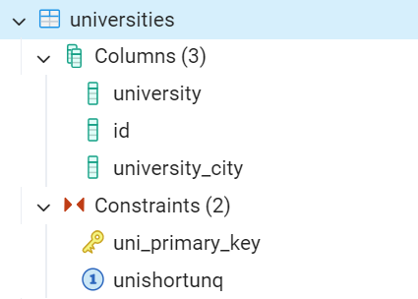

- Frontend Screenshots
Attach screenshots of the frontend user interface of your system. Show different screens that the users will interact with.
- Example Queries and the outputs(create , Insert, update, delete , joins, referential integrity)

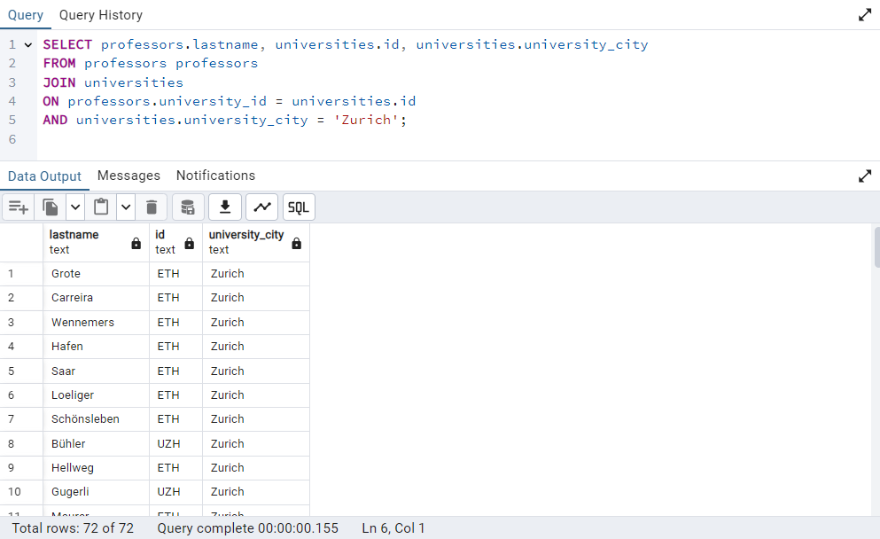

- Project Files

-- Select all professors working for universities in the city of Zurich
SELECT professors.lastname, universities.id, universities.university_city
FROM professors professors
JOIN universities
ON professors.university_id = universities.id
AND universities.university_city = 'Zurich';

-- Set professor_id to professors.id where firstname, lastname correspond to rows in professors
UPDATE affiliations
SET professor_id = professors.id
FROM professors
WHERE affiliations.firstname = professors.firstname AND affiliations.lastname = professors.lastname;

